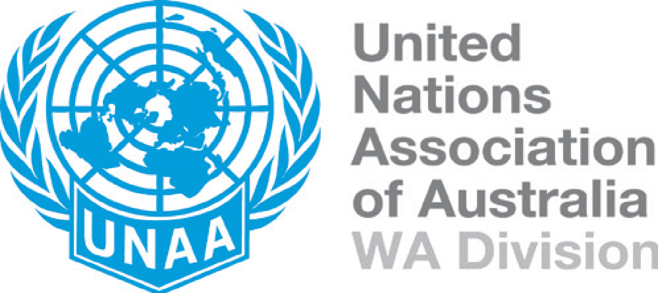
WEBSITE: www.unaa-wa.org.au
EMAIL: gender.equality@unaa-wa.org.au

2022 United Nations Association of Australia Gender Equality Committee – UN Day Awards

NOMINATION FORM

How to nominate

Any individual may submit a nomination, or any individual may be nominated by someone. Each nomination must be submitted on a separate form. Incomplete forms may be considered ineligible for assessment.

Send your completed form to:

WA Gender Equality Committee Chair
United Nations Association of Australia
Email: gender.equality@unaa-wa.org.au

Applications close

8th July 2022

Award criteria

We are looking for qualities that reflect the values of gender equality promotion:

- Contributes to the advancement of women’s rights, women’s leadership and women’s economic empowerment.
- Shows commitment to advancing gender diversity and providing equal opportunities to women and men.
- Demonstrates exemplary leadership by providing mentorship and education to females and inspires others to promote gender equality.
- Demonstrates the spirit of volunteerism.

Section 1: Nominee Details

Please provide us with the nominee’s details by completing the sections below and attach a copy of the nominee’s resume and photo. Please ensure the photo is high resolution.

Nominee details

First name: | Surname:
Nominee’s phone number:

Organisation (if applicable):

Position:

Nominee’s email address:

Nominated by

Name:

Organisation:

Address:
(include postcode)

Telephone:

Mobile:

Email:

Relationship to nominee:

Signature:

Date:

Section 2: Supporting Evidence

Nominees must provide us with no more than a 3-page Word document, speaking to the award criteria. Please outline the nominee’s contributions towards the upliftment of women and support of any of the sustainable development goals. Please ensure your answer includes a few examples of the role/s the nominee has played in the community, including the outcomes achieved.
Please ensure that evidence demonstrating the nominee’s achievement of excellence in gender equality promotion is attached to the nomination form. This supporting evidence includes a submission of up to three photographs and up to three supporting documents. Supporting evidence from the last two years may be used.
Note that attachments should not exceed 4MB in total. If the total size of the files you wish to submit exceeds 4MB, your entry may not be received correctly. If the entry materials exceed the 4MB limit and the size cannot be reduced, please contact Hannah Brown on 0408 703 693 or via email at gender.equality@unaa-wa.org.au to discuss an alternative option. Please note that any materials submitted will not be returned.

Section 3: Referees

Please provide the name, position and contact details for up to three referees. Please advise referees that members of the judging panel may contact them during the selection process.

Referee details

Referee one
First name: | Surname:
Referee’s phone number:

Organisation (if applicable):

Position:

Referee’s email address:

Referee two
First name: | Surname:
Referee’s phone number:

Organisation (if applicable):

Position:

Referee’s email address:

Referee three
First name: | Surname:
Referee’s phone number:

Organisation (if applicable):

Position:

Referee’s email address:

Section 4: Terms and Conditions

Please read the nomination terms and conditions and agree before submitting.

- All nominations/ entries and nominee details remain confidential and cannot be used for purposes external to the UNAAWA Awards process unless otherwise formally negotiated.

- Nominees are responsible for determining their eligibility and the most appropriate category in which to apply. Individuals and groups may enter.

- Any nominations received without all relevant information will not be considered. It is each nominee’s responsibility to ensure that all supporting evidence is correctly attached and submitted.

- Nominees agree to being contacted by a UNAAWA representative, and to have their referees contacted, to verify any information submitted.

- Nominees will declare any conflict of interest with the values of the UNAAWA.

- Nominees agree that legal complaints, any Court action, challenges to the accuracy, corrections or claims of plagiarism, demand or claim arising out of intellectual property of any other legal proceeding or demand relevant to the entry shall be forthwith disclosed to the UNAAWA.

- By submitting this form, the nominator acknowledged that they have received consent from the nominee that if they are the recipient of the Award, they will provide a short interview for the UNAA-WA website, and be willing to participate in promotional activities.

- All nominees retain responsibility to not engage in conduct which brings or has the potential to bring the UNAA-WA into disrepute.

- The winner agrees to accept their award in person at the UN Day Gala event held in October 2022 in Perth.

- It is acknowledged and represented by the nominees that they possess exclusive lawful intellectual property rights in relation to all aspects of the entry.

- It is acknowledged and represented by the nominees that all the information in the entry is true and correct and that the nominees are duly authorised by all relevant parties to lodge the entry.

- All nominees must agree to abide by the decisions of the judges and no appeals will be entered into.

- All award winners will be expected to accept an ambassadorial role to promote the awards.

- Nominees agree to be contacted by the media for ‘good news’ stories, should they be named a finalist or overall winner of the UNAAWA UN Day Awards.

- Nominees agree for their photographs, profiles and other details to be used for promotional purposes by the UNAAWA. Information about winners and their photographs may be published on the UNAAWA website and/or in external publications.

- Nominees agree that, if they are selected as finalists, representatives of the judging panel may visit to observe and discuss aspects of their work and/or their project(s).

Name (Print): Date:

Signature:

Section 5: Entry Form Checklist

Please ensure you have completed all requirements before submitting your entry.

Submission - up to three (3) pages attached (in Word or PDF format) detailing

achievement of excellence in gender equality promotion (defined as a very high
standard of innovation and effectiveness in gender equality promotion) Tick the box to indicate attachment of submission.

Photographs - up to three (3) photos attached (in JPEG, PNG, or TIF format) relating to gender equality promotion contributions and/or outcomes. Write the number of photos in the box.

Other Items - up to three (3) additional items attached (such as a graph, video promo, letter of recommendation, report, etc.) included as evidence to illustrate or describe the program and/or outcomes, Audio-visual material may be provided as active link(s) to the video/audio file(s). Other documents may be provided in Word, PDF, JPEG, TIF or PNG formats. Write the number of other items in the box.

Referees – up to three (3) referees have been provided.

Terms and Conditions – the terms and conditions have been read and agreed to.

