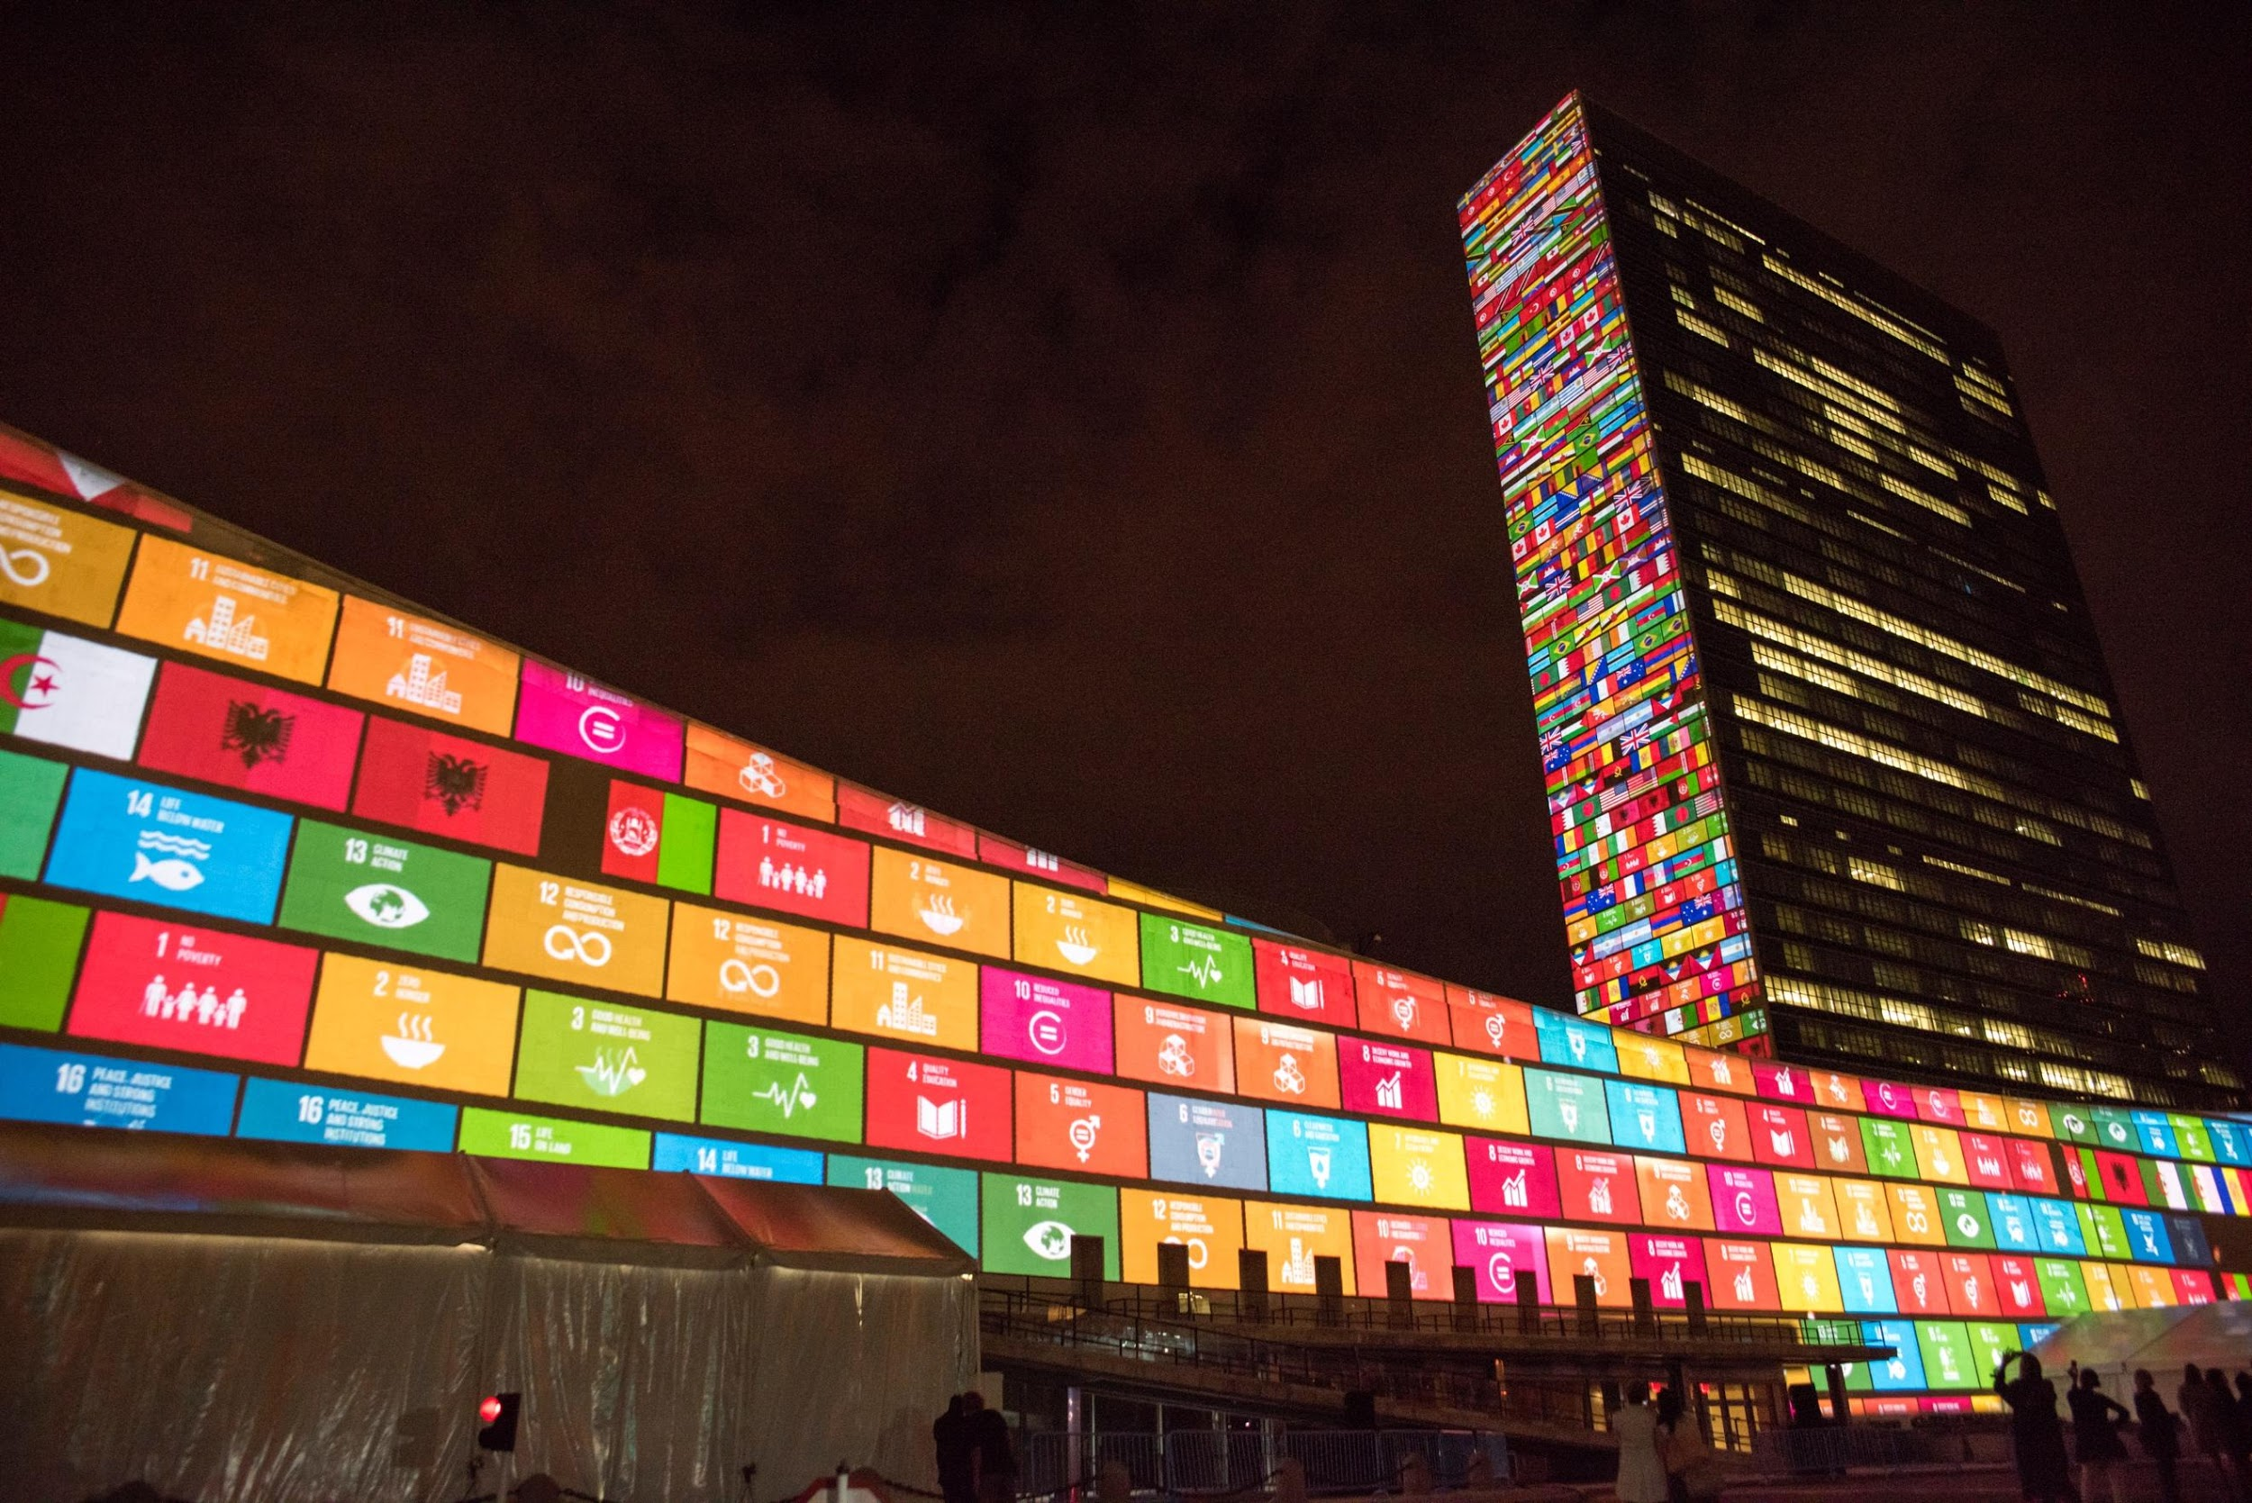
E
UN GALA EVENING 2021
EXCELLENCE IN HUMAN RIGHTS PROMOTION AWARD

22ND
OCT
2021

AWARD NOMINATIONS OPEN

The UNAAWA Human Rights Committee works towards increasing the awareness, greater understanding, and responsiveness towards human rights issues of local and global interest. The Excellence in Human Rights Promotion Award recognises local individuals and/or organisations who demonstrate an outstanding contribution to the promotion of human rights.

Any individual or organisation may submit a nomination or be nominated by someone.

NOMINATION PROCESS:

NOMINATION FORM: Complete the nomination form, outlining the details of the nominee and their referees.
SUPPORTING EVIDENCE: Attach the nominee’s resume, a high-definition photo, and a document outlining their contributions.
SUBMIT: To the Human Rights Committee Convener via email at human.rights@unaa-wa.org.au

TIMELINE FOR THE AWARD:

APPLICATION OPEN: 13 August 2021 applications open
APPLICATION CLOSE: 1 September 2021 applications close
ANNOUNCEMENT OF FINALISTS: October 2021
PRESENTATION OF AWARD: 22 October 2021 at the UN Day Gala Evening to be held at WA Museum Boola Bardip

Western Australia Division Incorporated member, World Federation of United Nations Associations.
Ph: (08) 9221 7020
ABN 63106 415 035
Western Australia Division Incorporated member, World Federation of United Nations Associations.
Ph: (08) 9221 7020 ABN 63106 415 035

